ShadeMates

Product Document
Smarter routes. Cooler journeys.
Presented by TP41 HelloWorld Inc. | FIT5120 Capstone Project 2026 S1

Contact Matrix
Role | Name | Email / Contact | Availability
Project Manager | Yosar Fatahillah | yosa0004@student.monash.edu | Weekdays (9AM-6PM)
Support Lead | Ruwang Lin | rlin0044@student.monash.edu | Weekdays (9AM-6PM)
Technical Lead | Jiahui Qing | jqin0020@student.monash.edu | Weekdays (9AM-6PM)
Data & AI | Xinyu Fan  Qi Yu | xfan0060@student.monash.edu  qyuu0028@student.monash.edu | Weekdays (9AM-6PM)
Security Contact | Raden Musa Saleh | rsal0026@student.monas.edu | Weekdays (9AM-6PM)

Table of Contents
1. Product Overview 2
1.1 The Problem 2
1.2 The Solution 2
1.3 Target Audience 2
2. Team Information 3
3. Ethics Canvas & ACS Code of Conduct Alignment 3
3.1 Ethical Considerations 3
3.2 Ethics Canvas 5
4. Future Opportunities 5
4.1 Potential Sponsors 5
4.2 Product Roadmap 5
5. Handover Note 6

1. Product Overview

1.1 The Problem
Heatwaves are Australia's deadliest natural hazard, and urban areas within Melbourne's CBD can be up to 4–7°C hotter than surrounding suburban regions due to the Urban Heat Island (UHI) effect. Despite this, most residents - particularly vulnerable groups such as the elderly, daily commuters, and those with pre-existing skin conditions like melanoma - lack access to real-time, personalised information to help them navigate heat safely.
Standard weather apps report city-wide averages and do not account for micro-level temperature variation, shade availability, or individual health risk profiles. Poor route choices and a lack of timely heat warnings can directly increase heat-related illness, hospital admissions, and fatalities.

1.2 The Solution
ShadeMates is a mobile application designed to mitigate the Urban Heat Island effect for vulnerable Melbourne residents. The app provides:
- A real-time urban heat map visualised at suburb level, powered by OpenWeatherMap API and City of Melbourne open datasets.
- Personalised heat risk alerts based on the user's vulnerability profile (e.g. melanoma history, age, cardiovascular conditions), calibrated against Victorian Department of Health historical heat alert thresholds (2010–2022).
- Cooler walking route suggestions that minimise heat and UV exposure during commutes.
- A nearby cool places finder, sourced from open data on public facilities.
- Real-time UV Index monitoring and safe outdoor exposure duration tracking.
- A Shade Coverage Score per 200m grid cell, derived from tree canopy data covering 82,064 trees across 336 Melbourne CBD blocks.
- Heat education content including infographics and facts to improve user awareness and behaviour during extreme heat events.

Why ShadeMates is Different
Unlike general weather or mapping applications, ShadeMates is built specifically for heat-vulnerable users in Melbourne. It combines multiple open datasets, personalised health profiling, and actionable safety recommendations into a single, accessible interface - giving users a block-by-block answer to 'where is it safer to walk right now?' that no existing Melbourne tool provides.

1.3 Target Audience
ShadeMates is designed for heat-vulnerable Melbourne residents, with a primary focus on:
- Daily commuters with skin conditions (e.g. melanoma) - such as the representative persona Daniel Harper, a 42-year-old office worker who commutes between his apartment and Melbourne CBD and cannot afford unnecessary UV exposure.
- Elderly residents (65+) whose reduced sweat gland density and cardiovascular limitations place them at heightened risk during extreme heat events.
- Residents with cardiovascular conditions, for whom extreme heat triggers dangerous vasodilation and cardiac strain.
Secondary audiences include city planners, local councils, and public health organisations seeking data-informed tools to address urban heat vulnerability.

2. Team Information
ShadeMates was developed by HelloWorld Inc., a student team from Monash University as part of the FIT5120 Industry Experience Studio capstone project, Semester 1 2026.

Name | Student ID | Contact
Jiahui Qing | 35294019 | https://www.linkedin.com/in/jiahui-qing
Qi Yu | 34657592 | qyu0028@student.monash.edu
Raden M. Musa Saleh | 34430520 | id.linkedin.com/in/rm-musa-saleh-a147691a0
Ruwang Lin | 35049545 | rlin0044@student.monash.edu
Xinyu Fan | 35224193 | xfun0060@student.monash.edu
Yosar Fatahillah | 34582215 | au.linkedin.com/in/yosar-fatahillah

Product E-portofolio : Link
Product Video : Link
Live Build : Link
Project Governance Portfolio : Link

3. Ethics Canvas & ACS Code of Conduct Alignment

3.1 Ethical Considerations
As a health-adjacent application that processes real-time location data and personalised health profiles, ShadeMates has been designed with careful attention to ethical obligations. The team has identified six key ethical dimensions relevant to the product, mapped against the ACS Code of Professional Conduct.

Ethical Principle | Potential Harm / Risk | Mitigation / Design Decision | ACS Code of Conduct Alignment
Privacy & Data Minimisation | Epics 4, 5, 7: User location and health profile data (vulnerability type, skin condition, age) are collected to generate personalised alerts. This data could be misused or stored insecurely. | Location is processed in real-time and not stored persistently. Health profile inputs are user-controlled and session-scoped. API keys are stored in secure build-time config (not hardcoded). Production signing keys enforced from Iteration 3. | ACS 3.2 – Honesty; ACS 3.4 – Competence in handling personal data securely.
Inclusivity & Accessibility | Epics 1, 4, 6: The primary users (elderly residents, melanoma patients, daily commuters) may have low digital literacy or physical limitations that make complex interfaces unusable. | High-contrast, simplified UI aligned with accessibility standards. Heat alerts (Epic 4) use plain-language recommendations. Education content (Epic 6) uses infographics over text-heavy formats. Suburb-level heatmap (Epic 1) avoids overwhelming detail. | ACS 3.1 – The Public Interest; ACS 3.6 – Participation in society.
Accuracy of Health Information | Epics 4, 5, 6: Incorrect heat thresholds, UV index readings, or educational content could lead users - particularly those with melanoma or cardiovascular conditions - to make unsafe outdoor decisions. | Alert thresholds (Epic 4) are calibrated against Victorian Dept of Health records (2010–2022, CC BY 4.0). UV data (Epic 5) sourced from OpenWeatherMap API. Education content (Epic 6) references peer-reviewed medical sources (e.g. Journal of Thermal Biology, European Heart Journal). Known data limitations are documented. | ACS 3.2 – Honesty; ACS 3.3 – Social Implications of technology.
Environmental Responsibility | Epics 1, 7: Heavy cloud computation (AWS Lambda) for heatmap generation and tree canopy shade scoring could create unnecessary energy overhead if not optimised. | Time-locked edge caching reduces redundant API calls for recurring regional heatmap requests (Epic 1). Grid-based indexing minimises payload size for shade and sun exposure data (Epic 7). Computation is offloaded to server-side only when needed. | ACS 3.3 – Social Implications of technology; broader sustainability obligations.
Consent & Transparency | Epics 4, 5: Users may not fully understand that their entered health profile (e.g. melanoma history, cardiovascular condition) and real-time GPS location are being used to generate personalised risk alerts. | Clear in-app disclosures explain what data is collected and how it is used. Users explicitly input and control their vulnerability profile. No background data collection occurs. | ACS 3.2 – Honesty; ACS 3.4 – Competence and informed consent practices.
Equity of Access | Epics 1–7: Residents without smartphones, with poor mobile connectivity (e.g. in areas with weak signal), or without English language proficiency may be unable to access ShadeMate's benefits - despite being among the most heat-vulnerable. | Identified as a known product limitation. App is designed to function on low-end Android devices. Future roadmap includes council partnership for alternative access. Epic 6 education content is visual-first to reduce language barriers. Expansion to multilingual support is a post-MVP priority. | ACS 3.1 – Public Interest; ACS 3.6 – Participation in society.

3.2 Ethics Canvas
We use the Ethics Canvas below as a structured framework for identifying and addressing the ethical impacts ShadeMate may have on its users, affected communities, and broader society.

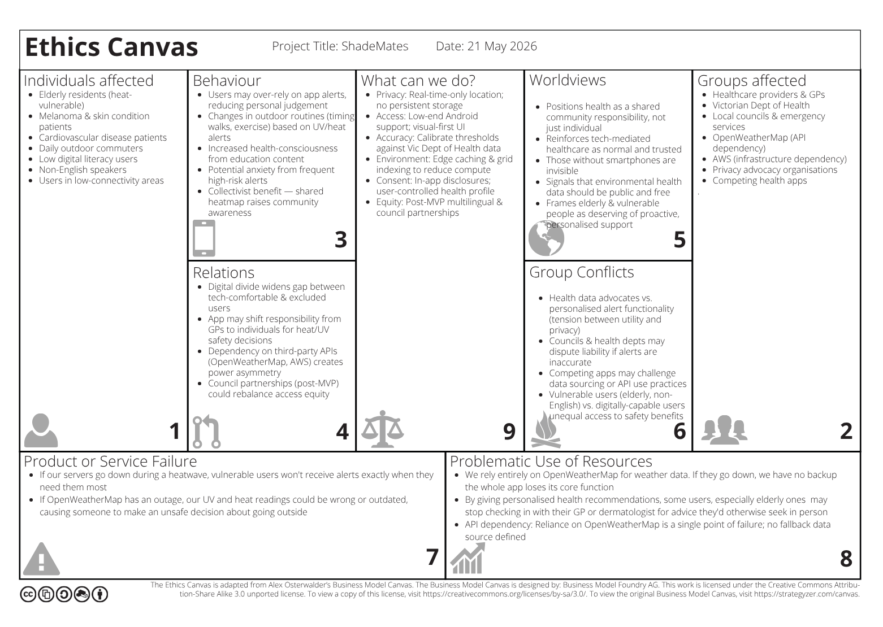

4. Future Opportunities

4.1 Potential Sponsors
Direct Mission Alignment
- City of Melbourne - aligns with urban heat and liveability strategy
- Victorian Department of Health - supports existing heatwave health response programs
- Local councils - Brimbank, Greater Dandenong, and other high-vulnerability LGAs

Grant & Research Bodies
- Lord Mayor's Charitable Foundation
- Australian Research Council (ARC) - Linkage Projects scheme

4.2 Product Roadmap
Once adopted by a sponsor, ShadeMates has a clear path for enhancement and broader impact:
- Smart city collaboration - potential integration with City of Melbourne digital infrastructure dashboards and emergency management systems.
- Integration with public transport data (PTV API) to provide platform-level heat warnings at Flinders Street, Southern Cross, and other high-traffic stations.
- Wearable and smartwatch notifications for real-time heat and UV alerts without requiring users to check their phone.
- Expansion to elderly and residential care populations, with simplified companion app versions for carers.
- Expansion beyond Melbourne CBD to other high-UHI areas such as Western Sydney and Brisbane's inner suburbs.

5. Handover Note
This Product Document forms part of the ShadeMates Handover Package, developed for FIT5120 Industry Experience Studio, Monash University, Semester 1 2026. It should be read alongside the Support Document and Maintenance Document included in the Project Governance Portfolio.
For sign-off and acceptance, please refer to the Handover Sign-Off Facility included in the Portfolio Repository.

Project Governance Portfolio
Google Drive Link:
https://drive.google.com/drive/folders/1gCSrOMbmeM8PZ7vJJ7WiYACLox4JD8PK

